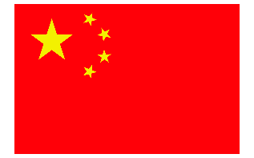
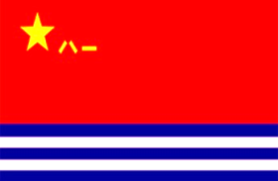

CHINA NAVY ESCORT IN GOA
APPLICATION FORM
Direction (west or eastbound)
Ship’s Name |  |  |  |  | Ship’ Flag Nation |  |  | IMO
Ship’s Name |  |  |  |  | Kind of Vessel |  |  | MMSI
Ship’s Owner (Company) and  Method of Contact（phone number/  E-mail address） |  |  |  |  | Cargo  (if loaded) |  |  | International Call Sign
Basic Particulars | Gross Tonnage |  | LOA | Mean Draft | Free board |  | Economical Speed | Max.  Speed |  | Situation of Loading
Ship Captain’s
Name and Country
Contact Details | INM-C |  |  |  |  |  | Crew's number and Nationality  (should be separated according to different country)
Contact Details | INM-FBB
Contact Details | Others
Contact Details | Email address
Contact Details | Person of Contact of Ship’s Owner (Company) and Contact Detail:
Last port of  Call/Country |  |  |  |  |  | Next port of Call/Country
ETA Rendezvous Point A (14-50N,053-50E) if Westbound
ETA Rendezvous Point B (11-52N 044-12E) if Eastbound
Place for helicopter landing or wheeling. And size of the Place.
Remarks |  | 1.Is there a citadel available on board. If yes, indicate location and Methods of Contact.  2. Is there security person on board? How many persons? Nationality?

