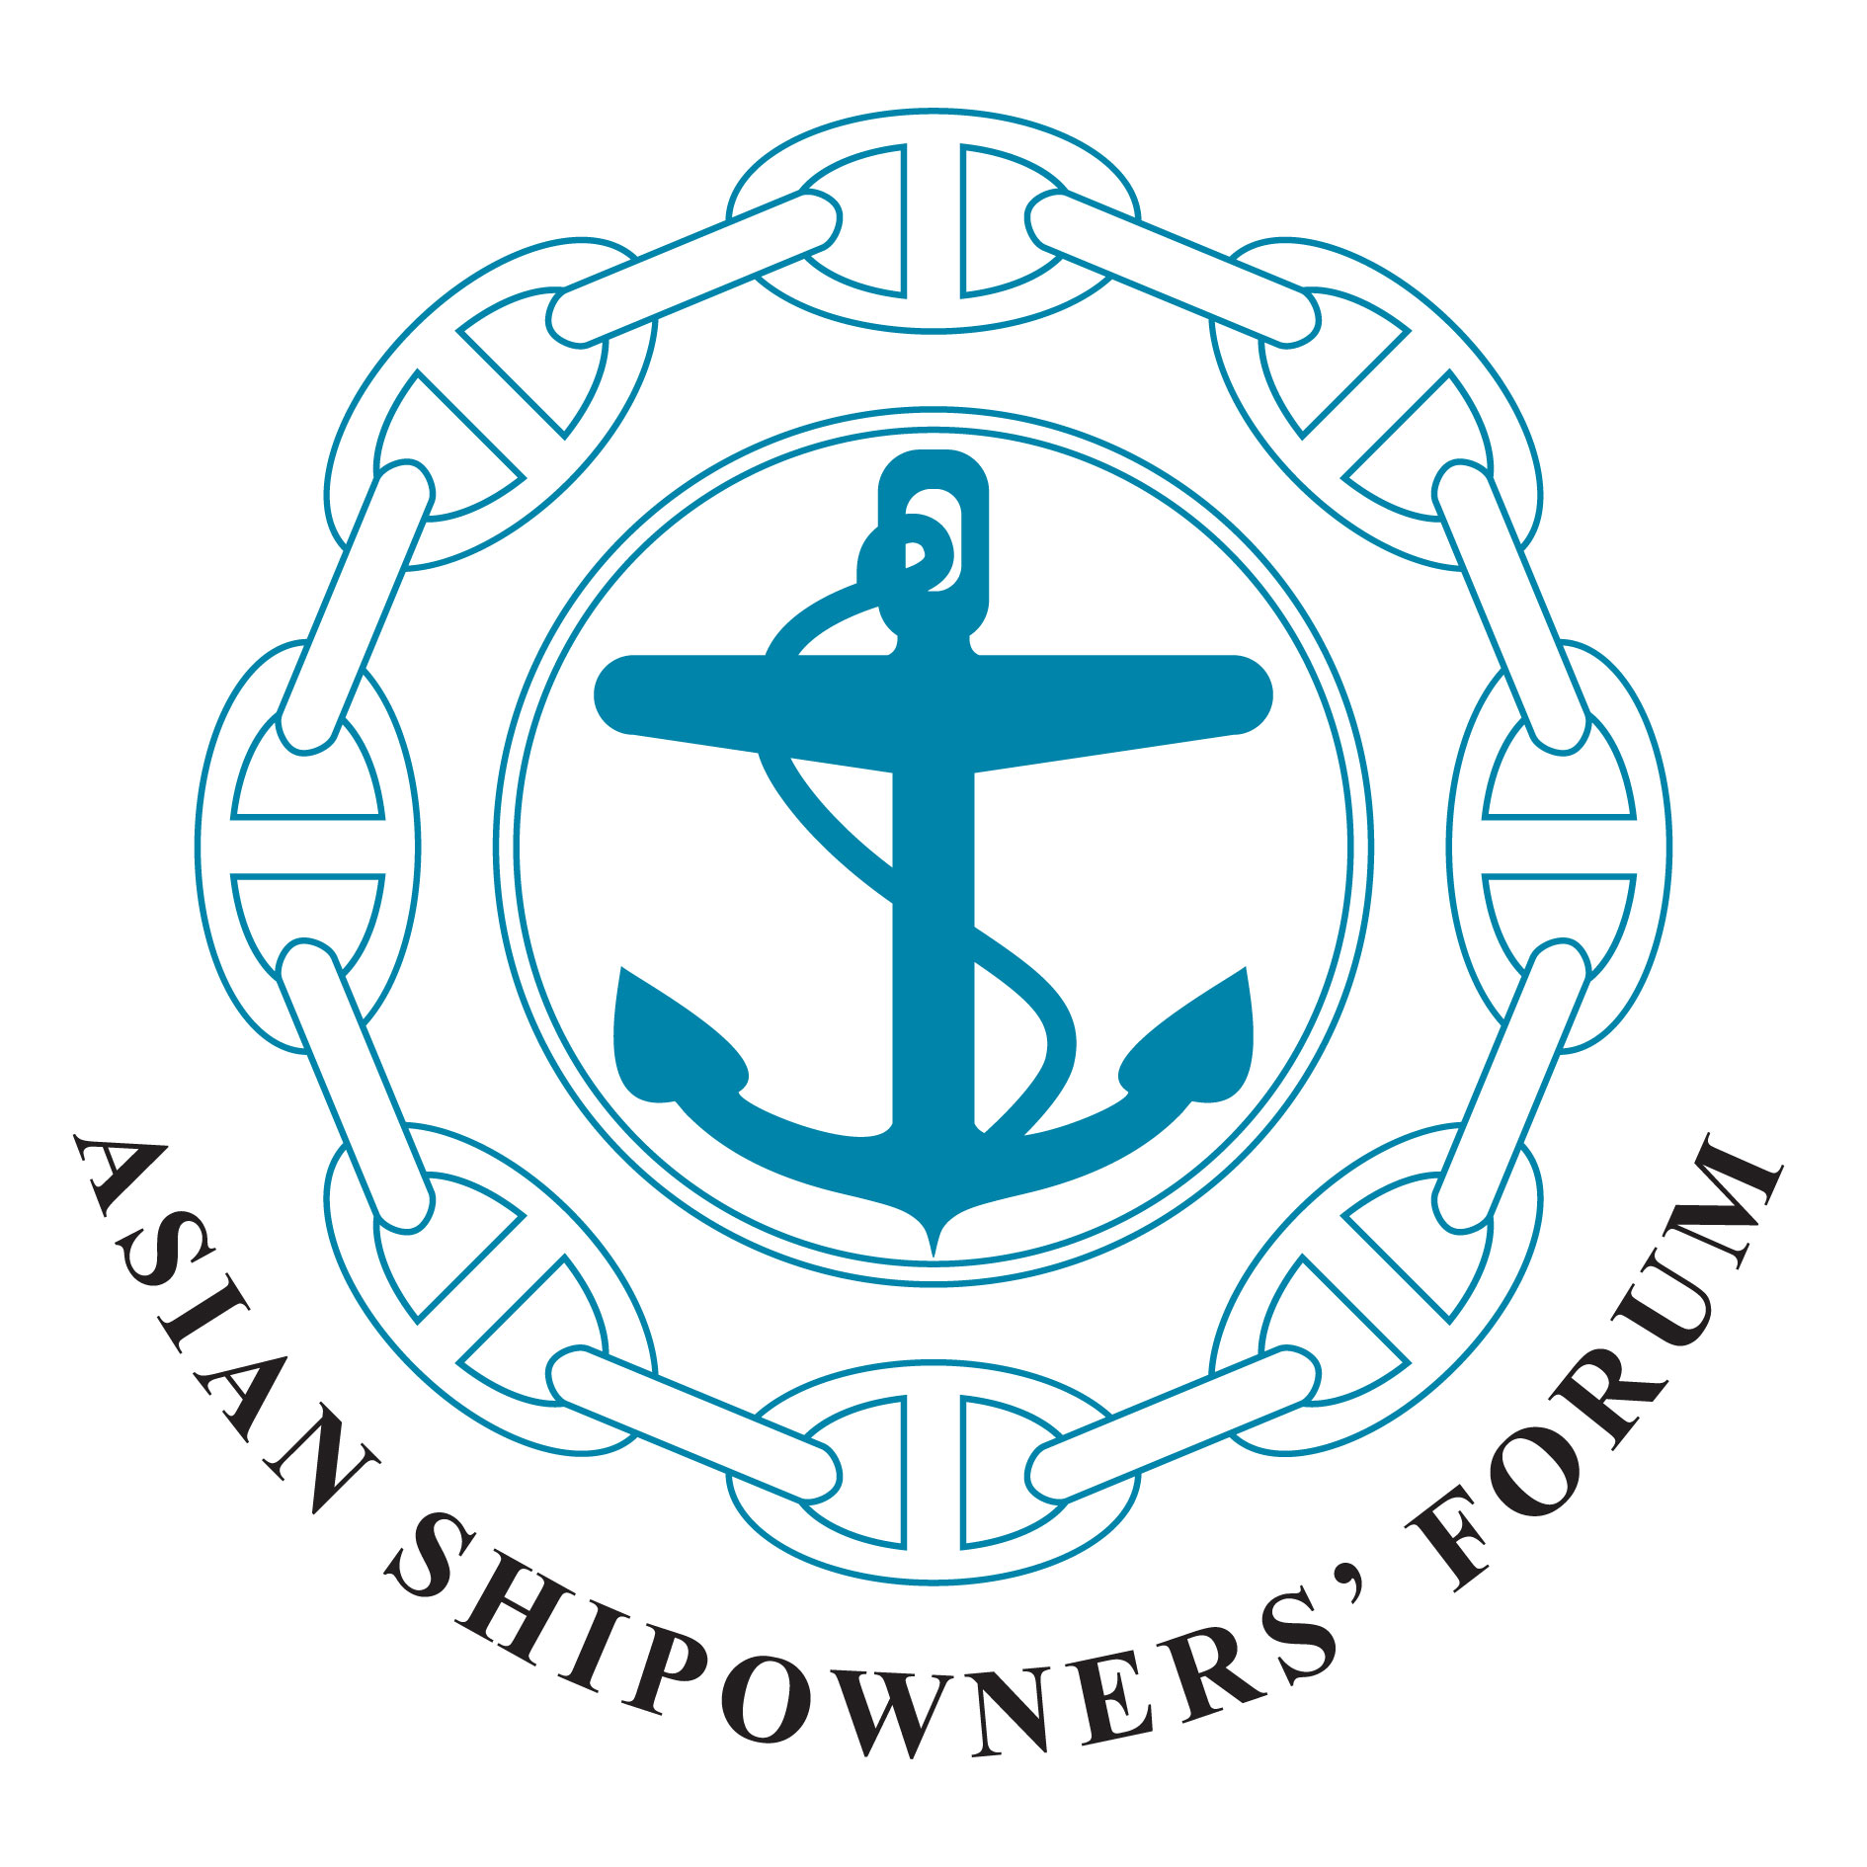
Asian Shipowners’ Forum
Ship Recycling Committee

c/o National Association of Chinese Shipowners
Rm. 508. 5th Fl. No. 10
Chung King S. Rd. Sec. 1
Taipei, Taiwan, R.O.C
E-mail: nacsn@ms39.hinet.net
Tel: +886-2-2311-0239 Fax: +886-2-2311-6924

23 March 2012, Jiaosi Yilan,Taiwan

Joint Statement
Adopted
at the 15th Interim Meeting of the Asian Shipowners’ Forum (ASF)
Ship Recycling Committee (SRC)

The 15th Interim Meeting of the ASF Ship Recycling Committee was held in Jiaosi Yilan ,Taiwan on 23 March 2012. The meeting was attended by the Secretary General of the ASF and eleven delegates from the ASF member associations of China, Chinese Taipei, Hong Kong, Japan and FASA as represented by Indonesia, Malaysia and Vietnam. The Association of Asian Classification Societies made a presentation to the meeting. The attendance list is attached.

The meeting was hosted by the National Association of Chinese Shipowners (NACS) and chaired by Mr. Bronson Hsieh, the Chairman of the ASF SRC.

The delegates expressed their appreciation to the NACS for arranging the meeting in Jiaosi Yilan, Taiwan.

- The SRC is pleased to note that the 2012 Guidelines for Safe and Environmentally-Sound ship Recycling and the 2012 Guidelines for the Authorization of Ship Recycling Facilities have been adopted at the IMO 63rd Marine Environment Protection Committee (MEPC63) meeting held in February 2012 to assist in the implementation of “Hong Kong International Convention for the Safe and Environmentally-Sound Recycling of Ships, 2009”.
The SRC encourages IMO member governments to ratify the Convention as early as possible.

- The ASF SRC encourages ASF Owners to develop and maintain the Inventory of Hazardous Materials (IHM) for their ships and recycle their ships following as much as possible the requirements of the Hong Kong Convention at acceptable and competent ship recycling yards.

- In this regard, the SRC recognizes the importance of sharing information on the development of IHM (i.e.; recognized organization, cost, time period, total number of approved IHMs, etc.) among the ASF members.

4. The adoption of Hong Kong Convention led to an increasing awareness towards safe and environmentally-friendly ship recycling in the world shipping industry, and it will require serious enhancement of the green ship recycling capacity which satisfies the standards of the Hong Kong Convention.
The SRC notes, however, that there is concern that the availability of green ship recycling yards and their capacity would be short in the near future.
In this respect, the SRC strongly encourages the major ship recycling countries to improve the ship recycling yards in their countries.

5. The SRC also agreed to further strengthen the exchange of information with concerned parties and the report of situation in each country on ship recycling.

6. Finally, it was confirmed that Asian shipowners, as major players in the global shipping industry, will continue to discuss ways in which shipowners can promote safer and more environmentally-sound ship recycling.

----------------

