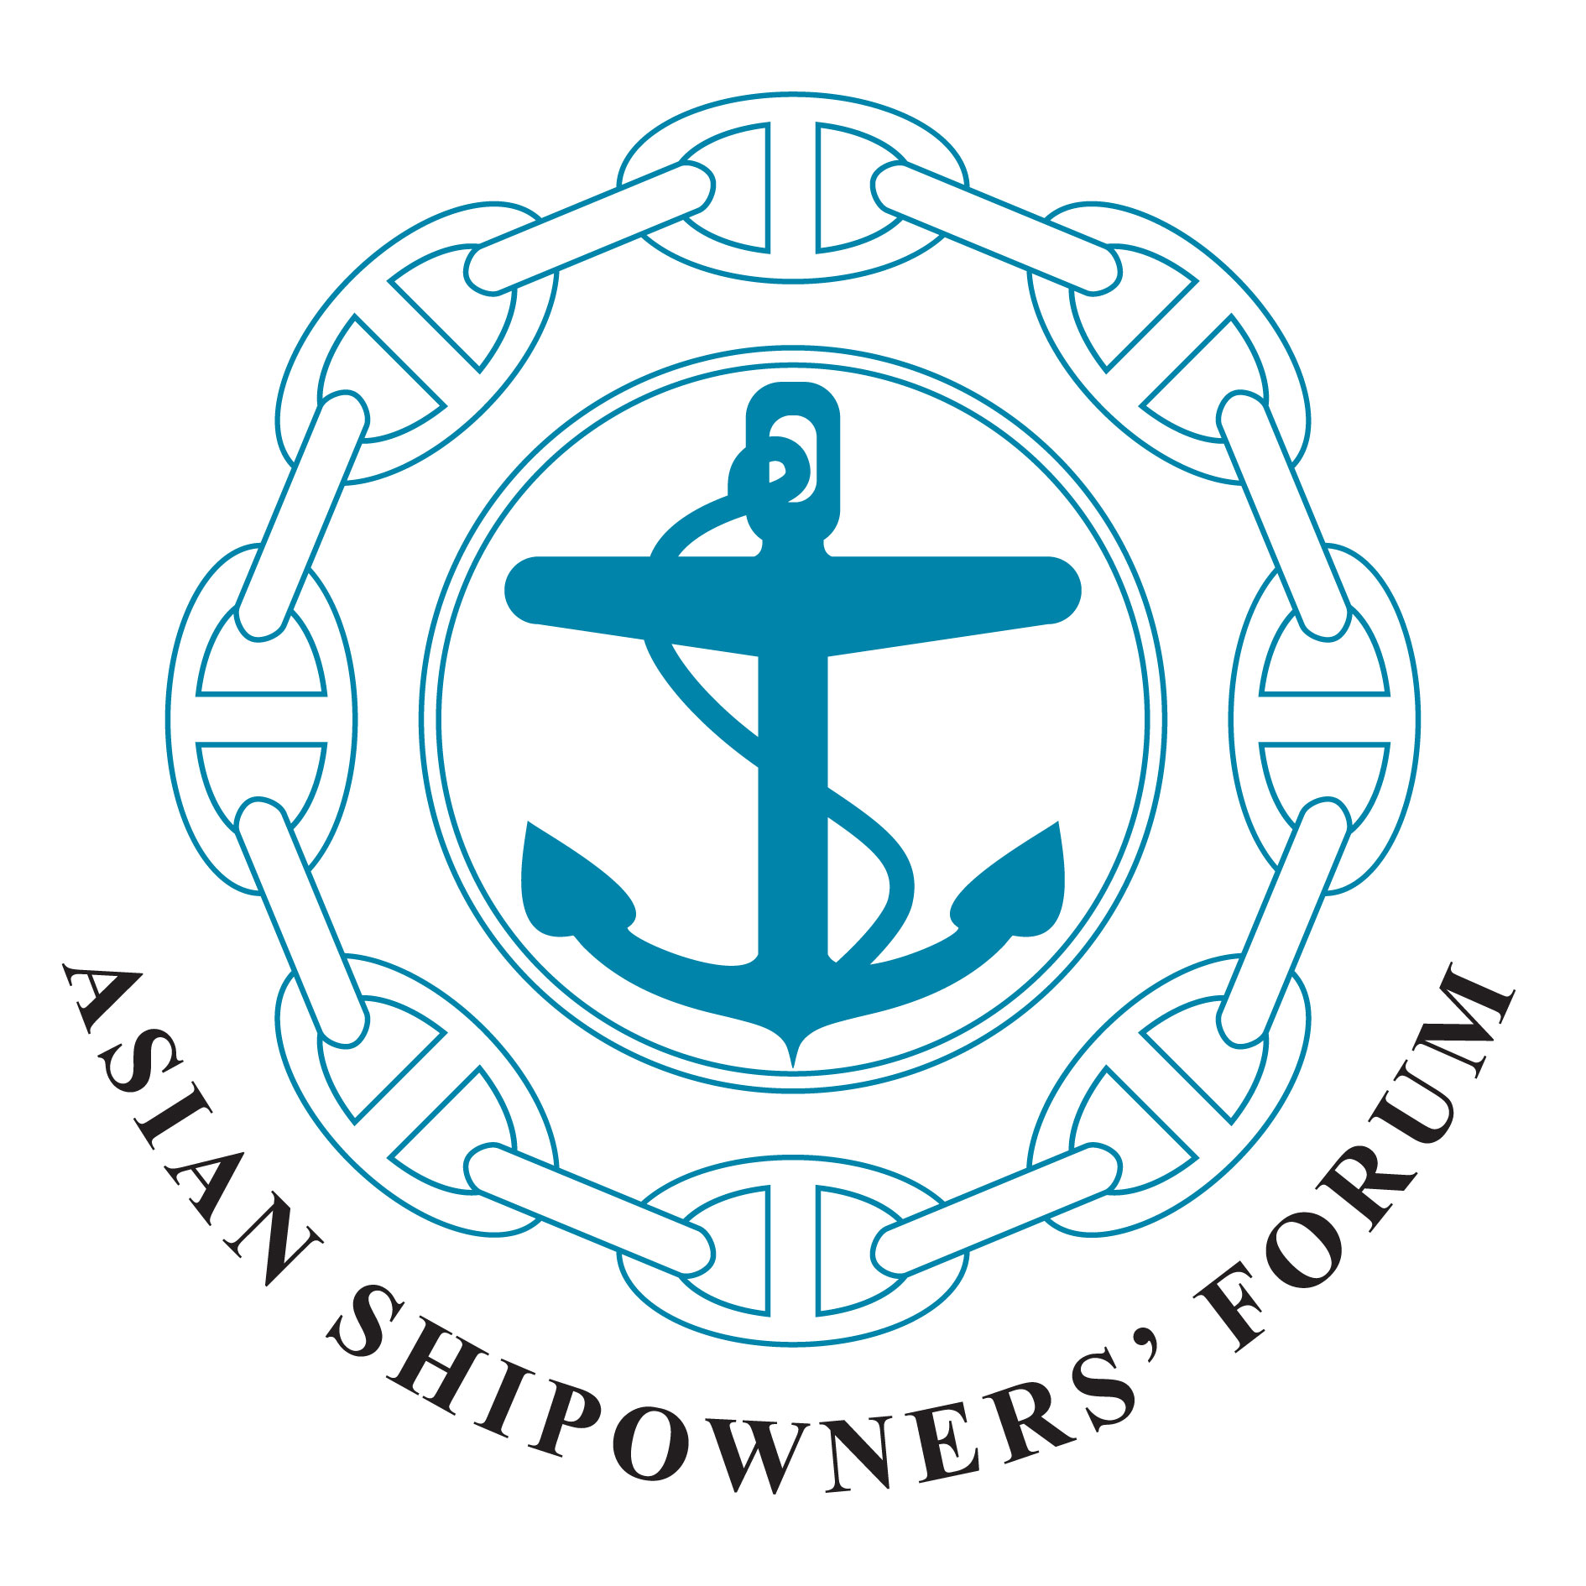
Asian Shipowners’ Forum
Ship Recycling Committee

c/o National Association of Chinese Shipowners
Rm. 508. 5th Fl. No. 10
Chung King S. Rd. Sec. 1
Taipei, Taiwan, R.O.C
E-mail: nacsn@ms39.hinet.net
Tel: +886-2-2311-0239 Fax: +886-2-2311-6924

18 March 2013, Taipei

Joint Statement (Final)
Adopted
at the 16th Interim Meeting of the Asian Shipowners’ Forum (ASF)
Ship Recycling Committee (SRC)

The 16th Interim Meeting of the ASF Ship Recycling Committee was held in Taipei on 18 March 2013. The Secretary General of the ASF and fifteen delegates from the ASF member associations of China, Chinese Taipei, Hong Kong, Japan and Malaysia attended the meeting. The attendance list is attached.

The meeting was hosted by the National Association of Chinese Shipowners (NACS) and chaired by Dr. Frank F. H. Lu, the Chairman of the ASF SRC and the Chairman of NACS. The delegates expressed their appreciation to NACS for arranging the meeting in Taipei.

- The ASF Competition Statement was announced before the discussion of the Meeting Agenda Items. The ASF SRC adopted the ASF Competition Statement and confirmed its compliance with the competition regulations and laws applicable.

- The SRC was pleased to note that the remaining two Guidelines, for the survey and certification of ships and for the inspection of ships, have been adopted at the IMO 64th Marine Environment Protection Committee (MEPC64) meeting held in October 2012, to assist in the implementation of the “International Convention for the Safe and Environmentally-Sound Recycling of Ships, 2009” (Hong Kong Convention). The SRC urges IMO member governments to ratify the Convention as early as possible.

- Under the provisions of the Hong Kong Convention, existing ships need to produce the Inventory of Hazardous Materials (IHM) within 5 years of the entry into force of the Convention. The SRC, however, recognizes that existing ships are encouraged to make arrangements to comply with the requirements of the Convention as soon as possible, including the development of the IHM. The SRC also appreciates the importance of sharing information on the development of the IHM (i.e. the recognized organization, the cost, time period, total number of approved IHMs, etc) among SRC members.

- Recently, the European Parliament is considering a proposal for the EU regulation on ship recycling. The proposals include the introduction of a levy to be charged on all ships of any flag calling at EU ports and the banning of the use of the ‘beaching method’ for ship recycling. The funds raised from this levy would be used for auditing ship recycling yards and drawing up a list of recycling yards that are compliant with the EU regulation on recycling.
The SRC expressed serious concern about these proposals. Members of SRC believe that the proposed EU regulation risks completely undermining of the Hong Kong Convention, and that the global implementation of the Convention is the only way to overcome the problems of the recycling industry.

- The SRC noted that the volume of ship recycling is forecasted to increase in the upcoming years and there is concern that the availability and capacity of green ship recycling yards in the near future may not be sufficient. In this respect, SRC welcomed various efforts by countries concerned, such as the proposed project on improving ship recycling yards in India which might be financed by Japan under the Official Development Assistance (ODA), and the technical cooperation between Bangladesh and Norway on safe and environmentally sound ship recycling.

- The SRC appreciates CSA for their proposal to hold the 17th ASF SRC Interim Meeting in China in 2014.

- Finally, it was confirmed that Asian shipowners, as major players in the global shipping industry, will continue to discuss ways in which shipowners can promote safer and more environmentally-sound ship recycling and exchange of information with concerned parties.

*********

